Creamy braised leek pasta
Serves: 2 as a main
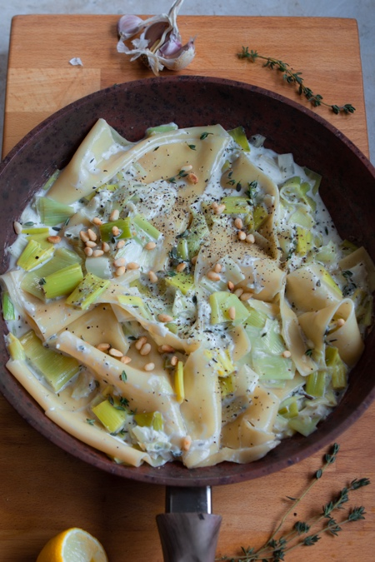

Ingredients:
3 leeks
10g fresh thyme
1 tbsp olive oil
4 cloves garlic minced
¼ cup boiled water
250ml single plant based or dairy (optional)
5 sheets lasagne pasta
¼ tsp pepper
½ tsp salt
Optional per portion:
Sprinkle of chilli flakes
1 tsp toasted pine nuts

Method:
- Chop the leeks into around 3cm thick circles and fry in a drizzle of olive oil with the fresh thyme and minced garlic for around 5 minutes
- Add the water and fresh thyme, pop on a lid and simmer for a further 5 minutes
- Whilst the leeks are simmering, add the lasagne sheets to a separate pan of water, add a pinch of salt and boil for around 5 minutes
- Add the cream to the leeks, turning the heat right down to ensure it doesn’t curdle, season, add the lasagne sheets and allow to combine for a further 2 minutes
- Check seasoning and garnish with a sprinkle of chilli flakes and toasted pine nuts

© Lucy Parker @lucy_and_lentils for The British Leek Growers’ Association (2019). For more leek recipes visit www.britishleeks.co.uk.

