Honey & mustard marinated leeks with almonds

Serves: 2 as a side dish

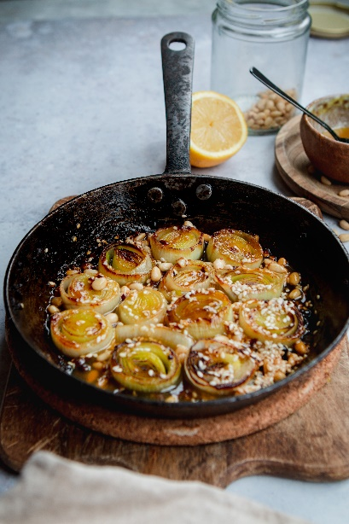

Ingredients:
1 large leek
3 cloves garlic minced
Dressing
1 tbsp honey
1 tsp dijon mustard
½ tsp salt
1 bsp brown miso paste (can substitute for tamari or soy sauce)
1 tsp olive oil

Method:

- Add the dressing ingredients to a bowl and whisk together until combined
- Chop the leek into approx 5cm thick circles and mince the garlic. Add to the dressing and allow to sit for around 10 minutes
- Add to a frying pan and sizzle on a medium heat for around 5 minutes on each side, or until the leeks have started to caramelise and turn golden brown

© Lucy Parker @lucy_and_lentils for The British Leek Growers’ Association (2019). For more leek recipes visit www.britishleeks.co.uk.

