Leek & squash filo crown tarts
Makes: 12 pastry crowns

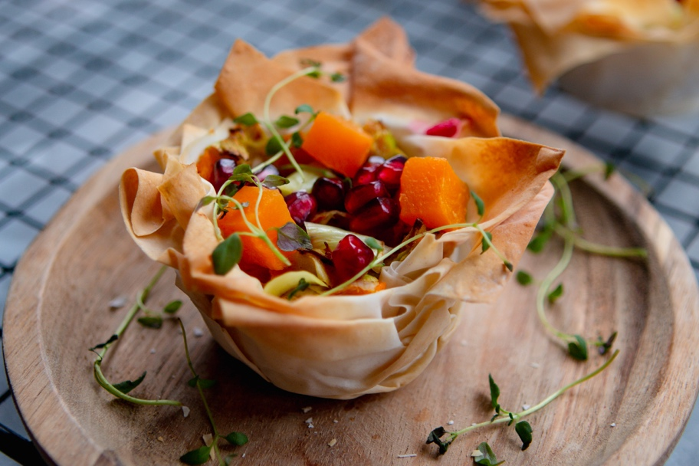

Ingredients:
2 leeks
1 butternut squash
4 cloves garlic
1 roll filo pastry quartered
Large pinch salt
1/2 tsp coriander
1 tsp mixed spice
1 tsp fresh thyme
Large pinch pepper
1 tsp olive oil

Method:
- Preheat the oven to 180ºC
- Slice the leeks (leaving 1 or 2 slices aside to garnish at the end) and squash, roughly chop and peel the garlic cloves and drizzle in olive oil and salt and roast for 25 minutes
- Quarter the sheet of filo pastry and using a non stick muffin tray, add one thin quarter and brush with olive oil then layer with another two sheets. Repeat until you’ve filled 12 of the muffin holes
- Take the sliced leeks, garlic and squash out of the oven and pulse in a food processor for around 10 seconds until just combined.
- Add the filling to the pastry and bake at 200°C for 10 minutes
- Top with the leftover leek slices, pomegranate seeds and a few sprigs of fresh thyme

© Lucy Parker @lucy_and_lentils for The British Leek Growers’ Association (2019). For more leek recipes visit www.britishleeks.co.uk.

