Baked salmon on a bed of leeks with roasted tomatoes

A stylish dinner that is so easy to make, this baked salmon cooks on a tray with a bed of tender leeks and vine tomatoes in less than half an hour, with barely three minutes of preparation time.

The ingredients are kept to a minimum because the beautiful salmon and leeks really need little else. The juices from the vegetables form their own sauce, resulting in a dish that’s sure to impress with next to no effort.

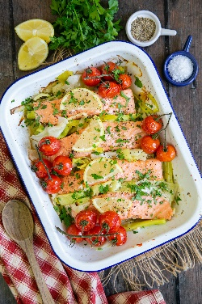
Serves: 4
Preparation time: 3 minutes
Cooking time: 27 minutes

- 2 large leeks (or 4 small ones)
- 2 tbsp olive oil
- 200–250g (1 punnet) vine tomatoes
- 4 salmon fillets
- 1 lemon
- fresh parsley to serve

Trim the leeks, discard any tough outer layers and cut into 3” / 8 cm pieces lengthwise. Then cut into quarters crosswise. If necessary, wash and then pat dry with a tea towel, or give your leeks a quick spin in the salad spinner.

Put the leeks into a medium roasting tin. Add the olive oil, season with pepper and salt, and toss well to coat them. Prick each tomato with the tip of a knife and place on top of the leeks.

Roast at 180 °C / 160 °C Fan / Gas Mark 4 for 12–15 minutes or until the leeks have started to soften.

Halfway through cooking, lift the tomatoes off, give the leeks a good stir. Then replace the tomatoes and return to the oven.

Add the salmon steaks, topping each with a slice of lemon, and return to the oven for a further 12 minutes until the salmon is cooked through.

To serve

Use tongs to arrange some of the leeks between each piece of salmon. Replace the lemon with fresh slices and scatter some freshly chopped parsley over to garnish.

Serve with mashed potatoes or rice.

Cook’s tips

Salmon can be skin-on skinless. I prefer skinless for ease of serving.

If the end of your fillet is very thin, fold it under when cooking. This will ensure that the fillet does not become dry at one end.

Leftovers

You can freeze any leftovers, which means that this recipe can serve two twice. Gently microwave to reheat.

Alternatively, enjoy the salmon with mayonnaise in a salad and whizz the remaining leeks into a soup.

Please credit www.Britishleeks.co.uk,

Recipe created and photography by Helen Best-Shaw of https://fussfreeflavours.com/

