Leek and Seafood Chowder

A truly satisfying meal in a bowl, this deliciously warming and nutritious soup makes the most of the sweet creaminess of gently cooked leeks. Using a supermarket fish pie mix avoids any messy fish preparation.

Serves: 4
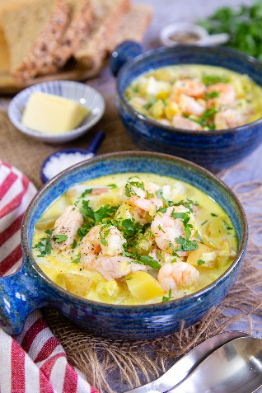
Preparation time: 5 minutes
Cooking time: 25 minutes

- 2 large leeks
- 100g bacon (3–4 rashers back bacon)
- 15g butter
- 1 tbsp olive oil
- 2 tbsp flour
- ½ tsp turmeric (optional, for colour)
- ½ tsp cayenne pepper (optional, adjust to taste)
- 600 ml fish stock (or weak chicken stock if you do not have fish stock)
- 400ml milk
- 200g potatoes (cleaned and diced, no need to peel)
- 320g packet of fish pie mix
- 150g packet of cooked prawns
- 4 tbsp cream
- fresh parsley (to garnish, optional)

Cut the leeks in half lengthwise, then into thin slices. If necessary, wash and then pat dry with a tea towel, or give your leeks a quick spin in the salad spinner.

Cut the bacon into 1cm pieces (I find the easiest way is a sharp pair of kitchen scissors).

Put the butter and olive oil in a frying pan and melt over a medium heat. Add the leeks and bacon and sauté for 5–10 minutes, stirring gently until the bacon is cooked and the leeks tender.

Add the flour, turmeric and cayenne pepper. Stir in and fry for two minutes.

Slowly add the stock, a little at a time, making a smooth paste. It is important to do this slowly to avoid getting lumps in the soup. Once the mixture is the consistency of single cream, transfer to a large saucepan.

Add the rest of the stock, the milk and the potatoes. Gently simmer for 15 minutes until the potatoes are cooked. Keep an eye on the pot, as simmering milk can easily boil over.

Once the potatoes are cooked, switch off the heat. Break up any larger pieces of fish. Then add the fish and prawns, stir in and cover the pan.

Leave for 5 minutes, allowing the fish to cook in the residual heat.

Add the cream and stir in well. If necessary, gently reheat before serving. Season to taste with pepper and salt.

Serve with an extra swirl of cream and a garnish of chopped parsley.

This soup is best served immediately and not reheated. If you feel there will be too much, you can halve the recipe and freeze the fish pie mix and prawns for another day.

Cook’s tips

For a gluten-free soup, you can use gluten-free flour.

Alternatively, leave the flour out and follow the recipe to the point where the potatoes are cooked.

Now put two tsp of cornflour in a bowl. Add a tablespoon of liquid from the soup mixture to the cornflour (NOT the other way around) and mix well so that they are well combined with no lumps.

Add the mixture to the soup and simmer, stirring until thickened to your preferred consistency. Then continue to follow the recipe above.

Please credit www.Britishleeks.co.uk,

Recipe created and photography by Helen Best-Shaw of https://fussfreeflavours.com/

