Creamy seafood pasta with leeks

This creamy leek and seafood pasta recipe is a quick and easy dinner for two that’s ready in a flash thanks to some “cheat” ingredients, but it feels like a treat. A packet of supermarket fish pie mix is the perfect fuss free way to get a variety of fish.

This dish makes a great after-work supper, as there is very little effort involved. It cooks in barely ten minutes. So delicious that you will want to make it again and again.

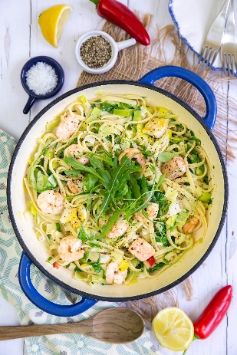
Serves: 2
Preparation time: 5 minutes
Cooking time: 10 minutes

- 1 large leek (or 2 small ones)
- 100g dried pasta (spaghetti, linguine or tagliatelle)
- 15g butter
- 1 tbsp olive oil
- ½ red chilli (to taste)
- 40 g garlic and herb cream cheese
- Juice of ½ lemon
- ½ x 320g packet fish pie mix (cut larger pieces of fish up)
- ½ x 150g packet cooked prawns
- 1 x 80g packet of fresh rocket leaves

Trim and clean the leeks, discard any tough outer layers and cut into discs.

Boil a large saucepan of water and add salt. Add the pasta and cook according to the packet instructions.

While the pasta cooks, melt the butter and olive oil together in a large frying pan on a medium heat. Gently soften the leek.

Add the chopped chilli, garlic and herb cream cheese and lemon juice. Skim off an espresso cup of the pasta water and add to the pan. Cook gently until the cheese is melted and you have a creamy sauce.

Now add the fish and prawns. Toss gently in the sauce so you don’t break the fish up and cook until you are happy that all the fish is cooked through. Drain the pasta (reserving some of the cooking liquid). Add the pasta to the sauce along with the rocket, reserving a few leaves to garnish. Toss to mix well. Add a little more pasta water if necessary to loosen the sauce.

Season well with black pepper to taste and scatter the remaining rocket over the top. Serve immediately.

Cook’s tips

You can use a little white wine instead of the lemon juice, if you have some open. For a dinner party, double the recipe and use fresh pasta!

Freeze the other half of both the fish pie mix and prawns for another time.

Please credit www.Britishleeks.co.uk,

Recipe created and photography by Helen Best-Shaw of https://fussfreeflavours.com/

