Leek & Button Mushroom Pot Pie

This makes a brilliant weekend lunch or dinner. Served either as one large pie or in individual pie dishes. I like mine with new potatoes and seasonal greens, but mash would be most welcome as there is a good amount of sauce. I use a 26cm pie dish, but a deep oven tray would also work, as long as your pastry sheet fits.

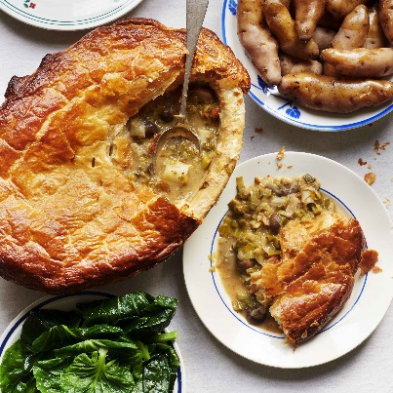
50g unsalted butter
2 carrots, diced
400g button mushrooms, any larger ones halved
6 leeks, 1-1.2kg, whites roughly sliced in 2cm sections, greens shredded
30g flour
400ml hot water
2 bay leaves
2 sprigs thyme, leaves picked and chopped
1tbsp Dijon mustard
1 egg beaten with 1tbsp milk
1 325g pack pre rolled puff pastry

Sea salt flakes and black pepper

- In a large saucepan melt the butter and add the carrots. Cook for 5 minutes. Then follow with the mushrooms for a further 5-7 minutes until starting to colour and the squeaking noise they make has stopped. Add in the leeks and mix well the combine. Cook for 5 more minutes.
- Stir in the flour and keep stirring for a minute or so. Add half the water and stir it in well. Add in the rest of the water the bay leaves and thyme. Bring the pan to a simmer for 2-3 minutes.
- Stir in the mustard, taste and add more mustard or salt to your tastes along with a good few grinds of black pepper. Pour the mix into your pie dish and chill in the fridge for 30-60 minutes.
- Set your oven to 240C/220C Fan/Gas 9. Remove and brush the edges with egg wash. Lay the pastry sheet over the top and press to secure in place. Depending how much is loose either fold the pastry edges underneath or neatly trim them off. Brush the top with egg wash and poke two holes in the top.
- Place in the oven and bake for 10 minutes before lowering the heat to 180c and continuing to cook for 30-40 minutes. Or until the pastry is risen, crisp and golden.

Please credit www.Britishleeks.co.uk, recipe, photography and styling by Joe Woodhouse

