Leek & Cheese Souffle

If you are scared of making soufflé, don’t be, these are really easy and very delicious. The cheese really comes through and is a perfect match for the buttery leeks hidden below. Serve them with new potatoes and watercress or I like a crunchy fennel salad with capers and parsley for a lighter option. If for a dinner party use 250ml ramekins. Otherwise, you can make this a sharing version in a pie dish, just add 10 minutes to the initial cooking time.
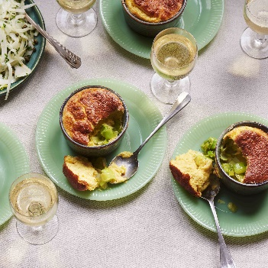
Serves 4

105g unsalted butter
500g leeks, cleaned, whites roughly sliced into 1-2cm rounds, greens shredded
60g flour, light brown adds a nuttiness, but any works
200ml full fat milk
125g cheddar, grated
4 medium eggs, separated
1-2 tsp Dijon mustard, or to taste.
Sea salt flakes and black pepper

- Set the oven to 220C/200C fan/Gas 7. Firstly, melt 30g of butter in a medium saucepan over a medium heat and add your leeks with a pinch of salt. Cook stirring occasionally for 5-7 minutes until soft.
- Meanwhile over a medium heat toast the flour in 60g of the butter for 2-3 minutes until golden and aromatic. Add half the milk and either with a spatula or a whisk incorporate it fully into the flour and butter. Add the rest of the milk and mix until a smooth roux is formed. Continue to stir over the heat until the sauce has thickened, 1-2 minutes should get you there. Take off the heat.
- Grease four 250ml ramekins with 15g of butter. Then finely grate 25g of cheese directly into the dishes to coat the sides as much as possible. Rotate the dish and coax any remixing cheese onto buttered areas to stick.
- Either by hand or in a machine whisk the egg whites to stiff peaks with a pinch or salt. Beat the egg yolks one at a time into the roux. Once fully incorporated mix through the cheese, mustard and a pinch of salt. Taste for the level of mustard you like, add more if needed. Stir the egg whites through the cheese mix a quarter at a time. Being careful not to knock out too much air from the egg whites, until fully incorporated.
- Divide your leeks evenly between the ramekins. Spoon the mix on top of the leeks. Set them in a high sided tray filled with 2cm of water. Place carefully in the oven and bake for 20 minutes. Turn the tray 180 degrees and continue cooking for 10-15 minutes until golden on top and set. Serve immediately.

Please credit www.Britishleeks.co.uk, recipe, photography and styling by Joe Woodhouse

