Leek & Potato Pancakes

These are a simple but satisfying meal. Either as two per person for a main or one each works as a starter for four. I like to combine the pancake ingredients in a blender, weighing out directly on the scales and blitzing until very smooth. That way you have a jug to pour from directly into the pan resulting in hopefully less mess. Otherwise with a whisk and mixing bowl also works fine.

Serves 4

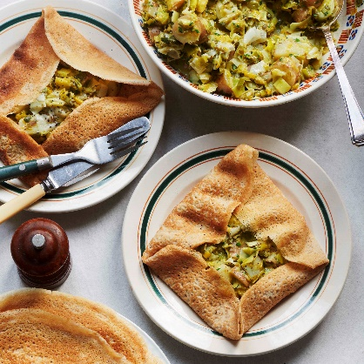
Pancake mix
2 eggs
30g oil, olive or sunflower are fine
350ml milk
175g spelt flour, buckwheat or other flour works fine as well
Pinch of sea salt

500g new potatoes
65g unsalted butter
6 leeks, 1-1.2kg, cleaned and whites cut into 2cm sections, greens shredded
25g chives, finely chopped
Sea salt flakes and black pepper

- Add the pancake ingredients to a blender and blitz until smooth, set aside to rest. In a pan cover the potatoes with water add a good pinch of salt. Set on a medium heat and cook until tender when pierced with a knife.
- In a medium saucepan over a medium low heat add the butter. Let it start to melt and then follow with the leeks and a pinch of salt. Cook for 5-7 minutes until just tender. Take off the heat.
- Set a large frying pan over a medium low heat. Add in a tbsp of the butter and swirl to coat the entire pan. Then pour in enough mix to cover the bottom of the pan while also rotating it to spread the batter out. Repeat until all the batter is used up. I keep the pancakes under a tea towel to help keep them warm.
- Depending how big your potatoes are either half or dice them. Mix with the leeks along with the chives and a few fruited of black pepper. Add more salt if needed.
- Spoon some leek and potato mix on to a pancake, pat down to form a rough square in the centre. Then fold the top and bottom in followed by the sides to create rough square parcels.

Please credit www.Britishleeks.co.uk, recipe, photography and styling by Joe Woodhouse

