Leek & Squash Bake with Parsley Crumble

This is a great centerpiece that can be prepped ahead. If you wanted to take it up a notch some grated cheese like gruyere or cheddar over the top is a lovely addition.

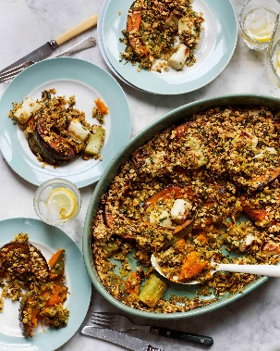
750g squash, about 800g whole weight, crown prince or
6 tbsp olive oil
500ml vegetable stock
6 leeks, cleaned, whites cut into 4cm sections, green tops shredded
180g flaked oats
1-2 tbsp cider vinegar
60g parsley, finely chopped
Sea salt flakes and black pepper
Crème fraiche or yogurt to serve

- Set the oven to 220C/200C Fan /Gas 7. Remove the seeds and cut your squash into 3cm width half moon sections. Place in a baking tray and drizzle with 3tbsp of oil and sprinkle of a pinch of salt. Move around to coat evenly in the oil and roast in the oven for 25-35 minutes, turning the squash pieces carefully halfway through.
- Meanwhile add the stock and the leek greens to a pan and set on a medium heat, let it come to a simmer. I place a steamer on top of the green leeks pan and cook the white parts of the leeks until tender. You can also blanch these in salted boiling water if you prefer. When the whites are done the greens are easily cooked as well. About 7-10 minutes depending how thick the leeks are.
- Either with a hand blender or in a blender blitz the leek greens to a smooth puree. Taste and add salt and vinegar to your taste. The mix wants to be the consistency of a thickish soup.
- In a large baking dish add in a couple of spoonfuls of the leek puree. Followed by arranging the squash evenly and dotting the white leek section around. Add the rest of the leek puree. Mix the remaining oil with the oats and parsley with a pinch of salt. Mix very well to coat the oats in oil and add on top of the leeks and squash. Bake in the oven for 30 minutes, then grill for a further 5 minutes to colour the top.

Please credit www.Britishleeks.co.uk, recipe, photography and styling by Joe Woodhouse

