Venison Steak with Creamy Leeks

Venison is an underused meat but if you want to get more free range meat into your diet, this lean, full-flavoured meat may be for you.

Venison steaks are extremely easy to cook and combine beautifully with the creamy leek and spinach bed. Cooking the leeks very slowly brings out the sweetness and makes the most of their delicate flavours.

Serve them with root vegetable mash or chips, as I have done here, and the result is a dish that is so much more than the sum of its very simple parts.

Perfect for date night or even St Valentines, this feels like restaurant food cooked at home without any fuss.

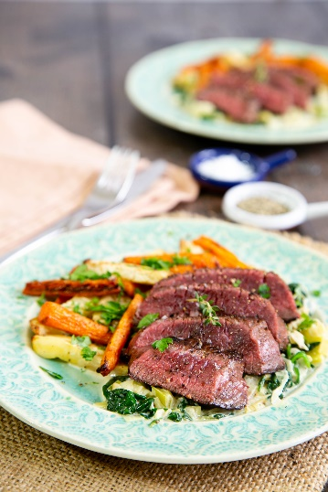
Serves: 2
Preparation time: 6 minutes
Cooking time: 45 minutes

For the creamy leeks
- 2 large leeks
- 15 g butter
- 1 tbsp olive oil
- 3 tbsp double cream
- 1 x 80g bag of baby spinach

For the carrot and celeriac chips
- 1 tbsp olive oil
- ¼ celeriac
- 2 large carrots

For the venison steaks
- 15g butter
- 1 tbsp olive oil
- 2 x venison haunch steak

Cut the leeks in half lengthwise, discard any tough outer leaves and then slice into ½ cm slices. Wash and then pat dry in a tea towel or give a quick spin in a salad spinner.

Put the butter and olive oil in a large heavy frying pan and sauté the leeks over a very low heat. Stir from time to time until they are very soft and reduced to about 30 % of the original volume.

As the leeks cook, prepare the root vegetables.

Wash, peel and chop the vegetables into chips. Put in a roasting tray with the olive oil, pepper and salt, and toss to coat well. Spread out evenly.

Cook in the oven at Fan 200°C/ 400°F / GM 6 for half an hour, turning half way through.

When the leeks are very soft and reduced, add the cream, the baby spinach and a splash of water. Then cover and turn the heat up for a minute, until the sauce is bubbling and the steam has wilted the spinach. Turn down, remove the lid and season to taste. Then allow to simmer to reduce to a rich and creamy mass.

Once you have reached this point and turned the root chips, you can start to cook the venison.

Heat the butter and oil over a high heat in a heavy frying pan until the butter solids are browning.

Add the steaks and allow them to sear in the hot pan. Do not move the steaks around in the pan whilst they are searing.

After 1 minute (for rare) or 2 minutes (for medium), flip the steaks over to cook the reverse side for the same amount of time.

Turn the heat right down and cook for a further 2–3 minutes. Remove from the pan and cover with a piece of foil. Allow to rest for 3–4 minutes before slicing and serving on the bed of creamy leeks with a sprinkling of sea salt.

Chef’s Tips

You can sauté down the leeks in advance and finish the dish while the venison is cooking.

This dish is equally delicious served with mash potato or celeriac.
Please credit www.Britishleeks.co.uk

Recipe created and photography by Helen Best-Shaw of https://fussfreeflavours.com/

