Fuss Free Flavours’ Leek, Bacon and Blue Cheese Quiche

Using ready-rolled pastry sheets makes homemade quiche a breeze, and it’s so much tastier than the ready-made versions that you can buy. This classic combination of flavours works a treat. I used a creamy mellow blue cheese, but you can choose your favourite.

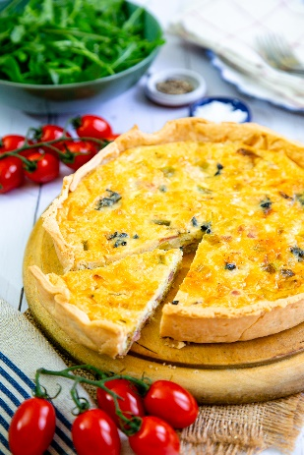
Serves: 2
Preparation time: 10 minutes
Cooking time: 50 minutes

Ingredients

For the crust:
- One packet ready rolled pastry (all butter is better)

Filling:
- 2 small leeks
- 3 rashers bacon
- 1 tsp olive oil
- 1 tsp butter
- 3 eggs
- 100ml double cream
- 50g grated cheddar cheese
- 50g soft creamy blue cheese

First blind bake the pastry crust

Take the pastry out of the fridge and allow it to come up to room temperature. You should be able to unroll it easily without cracking. Don’t put it anywhere too warm or it may become sticky.

Prepare an 8” / 20cm loose bottom flan or cake tin by greasing and flouring it.

Preheat the oven to 200°C / fan 180°C / Gas Mark 6. Lightly roll the pastry (on the paper) until it is wide enough to line the tin. Lift the pastry sheet over the tin and put into place so that it lines the flan tin neatly. Use a floured ball of pastry off cut to push the lining into the corners of the base and side of the tin. Use off cuts of pastry to fill any gaps or tears.

Prick the base of the pastry all over with a fork. As the pastry cooks, it will shrink so ideally the sides need to be taller than the sides of the flan tin.

Use the paper the pastry came on to line the inside of the pastry case. Use scrunched up rolls of foil to hold it against the sides, and to press down on the bottom. Alternatively you can use dried peas, beans or lentils, or ceramic baking beans if you have them.

Set the tin on a baking tray and transfer to the oven. Bake for 15 to 20 minutes, until the pastry is golden. Take out of the oven and lift the parchment paper and baking beans/foil out. Return to the oven for another 5 minutes.

If necessary, you can repair any holes in the pastry with offcuts of uncooked pastry. Use a serrated knife to neaten up the top of the edges.

Filling

While the pastry is baking, prepare the filling.

Prepare the leeks by cutting them in half lengthwise, discarding any tough outer leaves and chopping into ½ cm slices. Wash and then pat dry in a tea towel or spin in a salad spinner.

Cut the bacon into small pieces and sauté it in the oil and butter with the leeks until the bacon is golden and the leeks are soft.

Whisk the eggs and cream together in a bowl. Then add the leeks, bacon and grated cheddar. Stir together well and season generously with salt and pepper.

Pour the mixture into the prepared pastry case (leave it standing on a baking tray in case of leaks or spills). Don’t overfill the case but leave about ⅓” /½ cm clear around the top (do not over fill). Top with small pieces of the blue cheese.

Bake at 180°C/ fan 160°C / Gas Mark 4 for about 25 –30 minutes, until the filling has just set, is golden and has puffed up a little. Timings may vary a little according to the depth of your flan case, so check after 20 minutes and don’t be afraid to leave it in a little longer if necessary.

Remove from the oven and allow to cool for 10 minutes before lifting the quiche out of the baking tin to serve.

Please credit www.Britishleeks.co.uk, recipe, photography and styling Helen Best-Shaw, Fuss Free Flavours

