Leek Fried Rice

This is a staple in our house for any meal of the day. Mostly breakfast as it is so quick to bring together. Packed with veg it is fresh and healthy. I like to cook the egg first to keep it light and fluffy. You could easily leave out the egg and make it plant based.

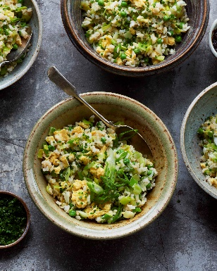
Serves 4
Preparation time: 5 mins
Cooking time: 10-15 mins

100g sunflower oil
1tbsp soy sauce, more for seasoning
4 eggs, beaten
500g leeks, trimmed weight
150g frozen peas, petit pois if possible
250g rice, brown short grain, cooked and cooled
1 bunch spring onions, finely sliced
15g chives, finely chopped
Sea salt flakes

Method

1. Heat a large frying pan or wok if you have one until it is smoking. Add about a third of the oil to the pan. Mix the soy sauce with the eggs and pour into the pan. Allow to cook for 15-20 seconds and then start pushing the edges into the centre to allow any uncooked egg to get to the oil. If needed break the omelette up into sections. Flip it to quickly finish cooking any raw egg mix. Carefully remove from the pan to a chopping board.

2. Add the remaining oil to the pan followed by the leeks with a good pinch of salt. Cook for 7-10 mins until the leeks are bright green and softened. Add in the peas and continue to cook for another minute. Then follow with the rice. Turn over to incorporate well, being careful not to break the rice grains too much.

3. After 2-3 minutes everything should be warmed through. Meanwhile chop the egg into a rough dice, 1-2cm is fine. Add to the rice and turn off the heat. Add in about 3/4 of the spring onions and chives. Reserve the rest for garnish. Mix everything well to combine, taste for salt levels, and add more soy if you like. Serve.

Please credit www.Britishleeks.co.uk, recipe, photography and styling by Joe Woodhouse

