Fuss Free Flavours’ Leek Galette

This easy but impressive rustic French tart is partly inspired by a Roman pizza bianca (without tomato), because it has potatoes on it! Yes – delicious double carbs!

Use leftover boiled potatoes and sausages together with a sheet of ready-rolled pastry and dinner will come together effortlessly, with no compromise on flavour. Add extra toppings according to what is in the fridge. A little blue cheese would be especially good.

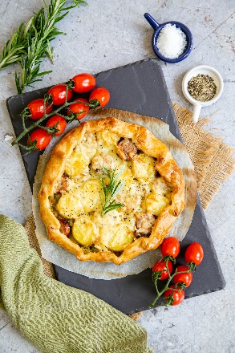
Serves: 2 for a hearty meal or 4 with vegetables on the side.
Preparation time: 10 minutes
Cooking time: 30 minutes

- One sheet ready-rolled shortcrust pastry (use all-butter pastry for best results)
- 2 large leeks
- 1 tbsp olive oil
- 15g butter
- 2 cooked sausages
- 4 boiled potatoes
- 50g strong cheddar cheese (grated)
- 1 egg, beaten (optional)
- Sprig fresh rosemary

Cut the leeks in half lengthwise, discarding any tough outer leaves. Then slice into ½ cm slices. Wash and then pat dry in a tea towel or give a quick spin in a salad spinner.

Put the butter and olive oil in a large heavy frying pan and sauté the leeks over a very low heat. Stir from time to time until they are very soft and reduced to about 30% of the original volume. Season well with pepper and salt. You can prepare the leeks ahead of time and keep it in a tub in the fridge for 3 days.

Allow the pastry to come to room temperature so that it can easily be unrolled without it cracking, but so warm that it becomes soft and sticky. Give it a few passes with the rolling pin to make it 2” / 5 cm wider, so you get a larger circular galette with a thinner crust.

Keeping it on the baking paper, cut the pastry in a rough circle, transfer to a baking tray, still on the baking paper (there’s no need to prepare the tin).

Add the cooked leeks, spreading them out but leaving a 2–3 cm border at the edge of the pastry. Top with sliced cooked sausages and potato. Sprinkle the grated cheese over.

Fold over the edges of the pastry over to make a border that overlaps the filling, making little crimps in it as you go. It doesn't need to be neat or even, as you want a rustic look.

Brush the pastry with beaten egg if you like a glossy finish. Bake at 200°C / Fan 180°C / Gas Mark 6 for about 30 minutes or until the pastry is cooked and the cheese golden.

Top with a fresh sprig of rosemary to serve.

Air fryer

Follow the instructions above but when you roll and shape the pastry, make sure it will fit in the air fryer basket.

Cook on the baking paper at 170°C for 18–20 minutes, checking after 15 minutes.

Allow to cool slightly in the basket for a few minutes before carefully removing to serve.

Please credit www.Britishleeks.co.uk, recipe, photography and styling Helen Best-Shaw, Fuss Free Flavours

