Leek Puff Pastry Slice

Think cauliflower cheese but with leeks and encased in puff pastry. Punchy and tangy with mustard and cheese, these are very addictive. I like to serve them with a salad spiked with quick pickled shallots that have been macerating in red wine vinegar to cut the richness. Cornichons or pickled walnuts work well also. I keep and freeze the pastry offcuts saving up batches to use at a later date rolled together for cheese straws or lining tart tins.
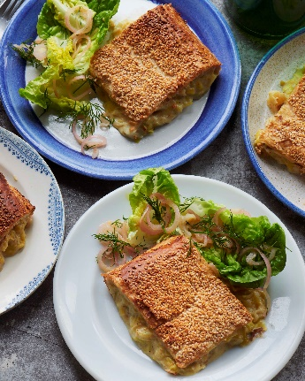
Serves 6
Preparation time: 15 mins
Cooking time: 1hr, plus 1 hr chilling and 15 mins resting

30g unsalted butter
30g plain flour
300g full fat milk
120g cheddar cheese, grated
1-2 tbsp mustard, Dijon or English work well
1/3-1/2 nutmeg
3tbsp olive oil
800g leeks, sliced 0.5-1cm rounds, trimmed weight
450g potatoes, cooked, cut into rough 1cm dice
2 packs 320g pre rolled puff pastry
1 egg beaten with 1tbsp milk
40g sesame seeds
Sea salt flakes and black pepper

Method

- In a medium sauce pan melt the butter with the flour and cook, stirring until golden and aromatic. Add in the milk and whisk together to form a smooth sauce. Cook until it is thick enough to coat the back of a spoon. Take off the heat. Stir in the cheese and the mustard to taste. Grate in the nutmeg and a few good grinds of black pepper to your taste. Set aside.
- In a wide base pan heat the oil over a medium high heat and add the leeks. Cook stirring often until the leek are vibrant green and softened. 5-7minutes should get you there.
- Stir the leeks into the sauce with the potatoes. You can carry on but it is best to chill the mix for 30 minutes or fully until you are ready to use it.
- Roll out the pastry sheets. Cut 4cm off the short end of one and 6cm off of the other sheets’ short end. Lay the longer one on a tray lined with baking parchment. Spoon on the leek mix leaving 2cm of space around the edge. Add the shorter pastry sheet on top and tuck in around the sides of the leek mix. Brush around the edges with the egg wash and fold the overlapping short sides up and onto the top sheet. Repeat with etc long sides to fully seal the mix inside the pastry.
- Brush the whole pie with egg wash and sprinkle over the sesame seeds to fully cover. Place in the fridge to chill for 30 minutes. Set the oven to heat to 220C/200C Fan /Gas 7 during this time. The pie can sit overnight in the fridge if you like to have it made ahead of time.
- Place the pie in the oven and cook for 35-45 minutes until golden and risen. I turn the tray in the oven 180 degrees halfway through cooking.
- Allow to rest once out the oven for 15 minutes or so before slicing.

Please credit www.Britishleeks.co.uk, recipe, photography and styling by Joe Woodhouse

