Leek Tempura with Noodles in Leek Broth

Tempura leeks are such a wonderful thing. Bright and juicy with a satisfying crunch from the batter. This goes down very well as a family meal. Mainly because everyone loves it but also because it can be mostly prepped in advance. To get even further ahead, I freeze the noodles and just cook straight from the freezer when I’m ready to use them.

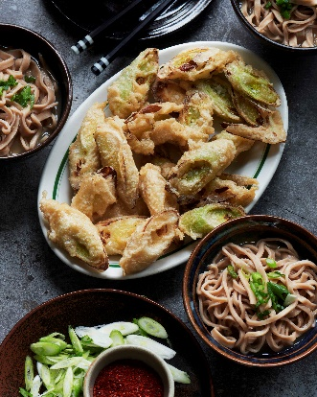
Serves 4
Preparation time: 20-30 mins
Cooking time: 20 mins, plus 30 mins -1 hr resting

450g unbleached white flour, standard plain flour works fine
10g sea salt flakes
700g leeks, trimmed weight
1 head of garlic, sliced in half across the equator
15g dulse seaweed
50g white miso
1.5litre sunflower oil
100g cornflour
100ml sparkling water
3 spring onions thinly sliced and chilli flakes to serve

Method

- First make the noodles. I use a mixer, but they easily come together by hand. Mix 400g of flour with 200g of water with the sea salt. Either in the mixer or by hand knead for 5-10 minutes until you get a smooth dough. Cover with a bowl and allow to rest for 30-60 minutes.
- Slice the whites of the leeks with diagonal cuts about 1-2cm in width. Set aside and cover until ready to use. Roughly chop the rest of the leeks and add to a pan along with the garlic, seaweed and 1.2 litres of water. Bring to a simmer. After 20 minutes turn off and cover. Leave as long as possible but minimum of another 30 minutes.
- Meanwhile cut the dough in half and roll each half out one at a time on a floured surface. Go as thin as you like, under 0.5cm is good. But thicker noodles are also great, go with what you like. Once rolled out dust with a little flour and fold the dough back on itself a couple of times. Then with a knife slice along the length to cut individual noodles. Gently pull apart to separate them and set aside. I freeze them at this stage if I’m not using straight away and cook straight from frozen.
- Strain the stock, you are after 600ml. If it is more, set on a simmer to reduce it to this amount. Turn off the heat and stir in the miso. Taste for seasoning and add salt if it needs it.
- In a wide high sided saucepan heat the oil to 180c. Mix the remaining flour with the cornflour, a pinch of salt and the sparkling water. Drop in a handful of leeks at a time. Push under to submerge and coat fully in batter. I use one hand to do this, shaking off excess batter and then gently drop them into the oil. It avoids getting too messy that way. Otherwise use a pair of tongs.
- Fry each leek for 60-90 seconds and then flip each over. Cook for a further 60 seconds. Or until the batter is golden and set and you can see the leeks beginning to colour underneath. Remove with the tongs or a slotted spoon to a plate with kitchen paper on to drain.

- Blanch the noodles for 1-2 minutes in salted water until tender. Drain and portion into bowls. Ladle over the broth. Top with some spring onion and serve alongside the tempura leeks.

Please credit www.Britishleeks.co.uk, recipe, photography and styling by Joe Woodhouse

