FUSS FREE FLAVOURS’ BEEF AND LEEK PIE

This easy and delicious winter beef and leek pie is rich and satisfying and makes a big impression, yet it’s easy to make with ready-rolled pastry sheets. Make the filling in advance for a really tender, succulent pie. I like to make a double batch of filling and freeze some to use later.

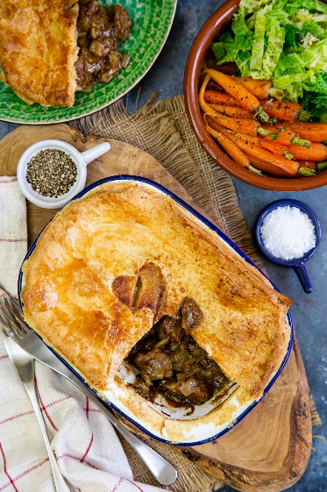
Serves: 4
Preparation time: 10 minutes
Cooking time: 3 hours, 15 minutes

Ingredients
For the crust:
- One packet ready rolled shortcrust pastry (all butter is better)
- 1 egg, beaten

For the filling:
- 2 tbsp beef dripping or olive oil
- 1 large onion
- 2 cloves garlic
- 2 leeks
- 400 g stewing/braising steak, cut into 1” chunks
- 2 tbsp flour
- 400 ml beef stock
- salt and pepper to taste

To make the filling
Peel and dice the onion. Melt the dripping in a heavy pan and gently fry the onion over a medium heat until fragrant.

While the onion is cooking, chop the leeks into discs, and peel and finely chop the garlic.

Add the leek and garlic to the onion and cook for another few minutes. Then transfer to a casserole dish. Leave the fat in the pan to cook the meat.

Fry the beef until it starts to brown. Leave space around the pieces so that they fry properly. If you crowd them, they may steam instead. To do this, you may need to cook the beef in batches, setting some aside while you cook the next batch.

Once all the beef is browned, return any of the meat that you removed to the pan, add the flour and give it all a good stir so that the beef is coated. Fry for a few minutes, stirring all the time until the flour is cooked.

Transfer everything from the pan to the casserole. Put a little of the stock into the frying pan to deglaze it, loosening any remaining bits of fat and meat, and then add this to the casserole dish along with the rest of the stock. Season well with salt and pepper and stir well to combine all the ingredients.

Put the lid on the dish and cook at 160°C/140°C fan/gas mark 3 for 2–2½ hours, until the beef is tender. Check halfway though and add a little more water or stock if necessary (you may need extra liquid if the casserole lid does not fit well).

Allow the filling to cool in the casserole dish. Then move it to the fridge where it can be left for up to 2 days before you make up the pie, or you can freeze it.

To make the pie

Preheat oven to 220°C/200°C fan/gas mark 7.

Remove the pastry from the fridge to allow it to come to room temperature. You should be able to unroll it without it cracking, but the pastry should not be sticky.

Transfer the filling to an 8” pie dish, leaving about 2 cm clearance at the top. Brush the edge of the pie dish with the beaten egg, cut narrow strips of pastry and place these on the edge of the dish. Now brush these with the egg and top with a piece of pastry covering the whole pie. Using your fingers or a fork, press down all the way around the edge to seal the pie crust. Trim any excess pastry and brush the top with the beaten egg.

Make a few slits in the centre of the pie with a sharp knife to allow the steam to escape.

Bake for 35–40 minutes, until the filling is piping hot and the pastry golden.

Chef’s tips
Make a double batch of the filling and freeze to use at a later date.

Add 100 g sliced mushrooms to make the dish go further.

To make the filling in the slow cooker

Prepare the filling to the point where you would transfer it to the oven but then place in the slow cooker.

Cook on high until gently simmering and then turn down low for 5–6 hours or until the meat is falling apart. If you need to thicken the filling, leave the lid ajar for the last 30 minutes of cooking.

To cook pies in the air fryer

I find individual pies work best and are easier to get in and out of the air fryer basket, so you will need four individual pie dishes.
Fill these with the beef and leek mixture (to 2 cm from the top) and top with a circle of pastry. Brush with beaten egg. Make a hole in the centre of the crust for the steam to escape.

Cook for 18–20 minutes at 160°C until piping hot throughout and the pastry is golden.

Please credit www.Britishleeks.co.uk, recipe, photography and styling Helen Best-Shaw, Fuss Free Flavours

