Heal Me Chicken Broth

There’s something deeply comforting about a pot of soup quietly simmering on the stove, isn’t there? This heal-me chicken broth feels so nostalgic for me as it reminds me of my mum’s homemade soups. British leeks bring a gentle sweetness and depth that are perfect for soup as they soften down beautifully, in a sweet, soft and silky way.
If you’re feeling run-down, short on time, or just craving something wholesome and nourishing, you need to make this broth.
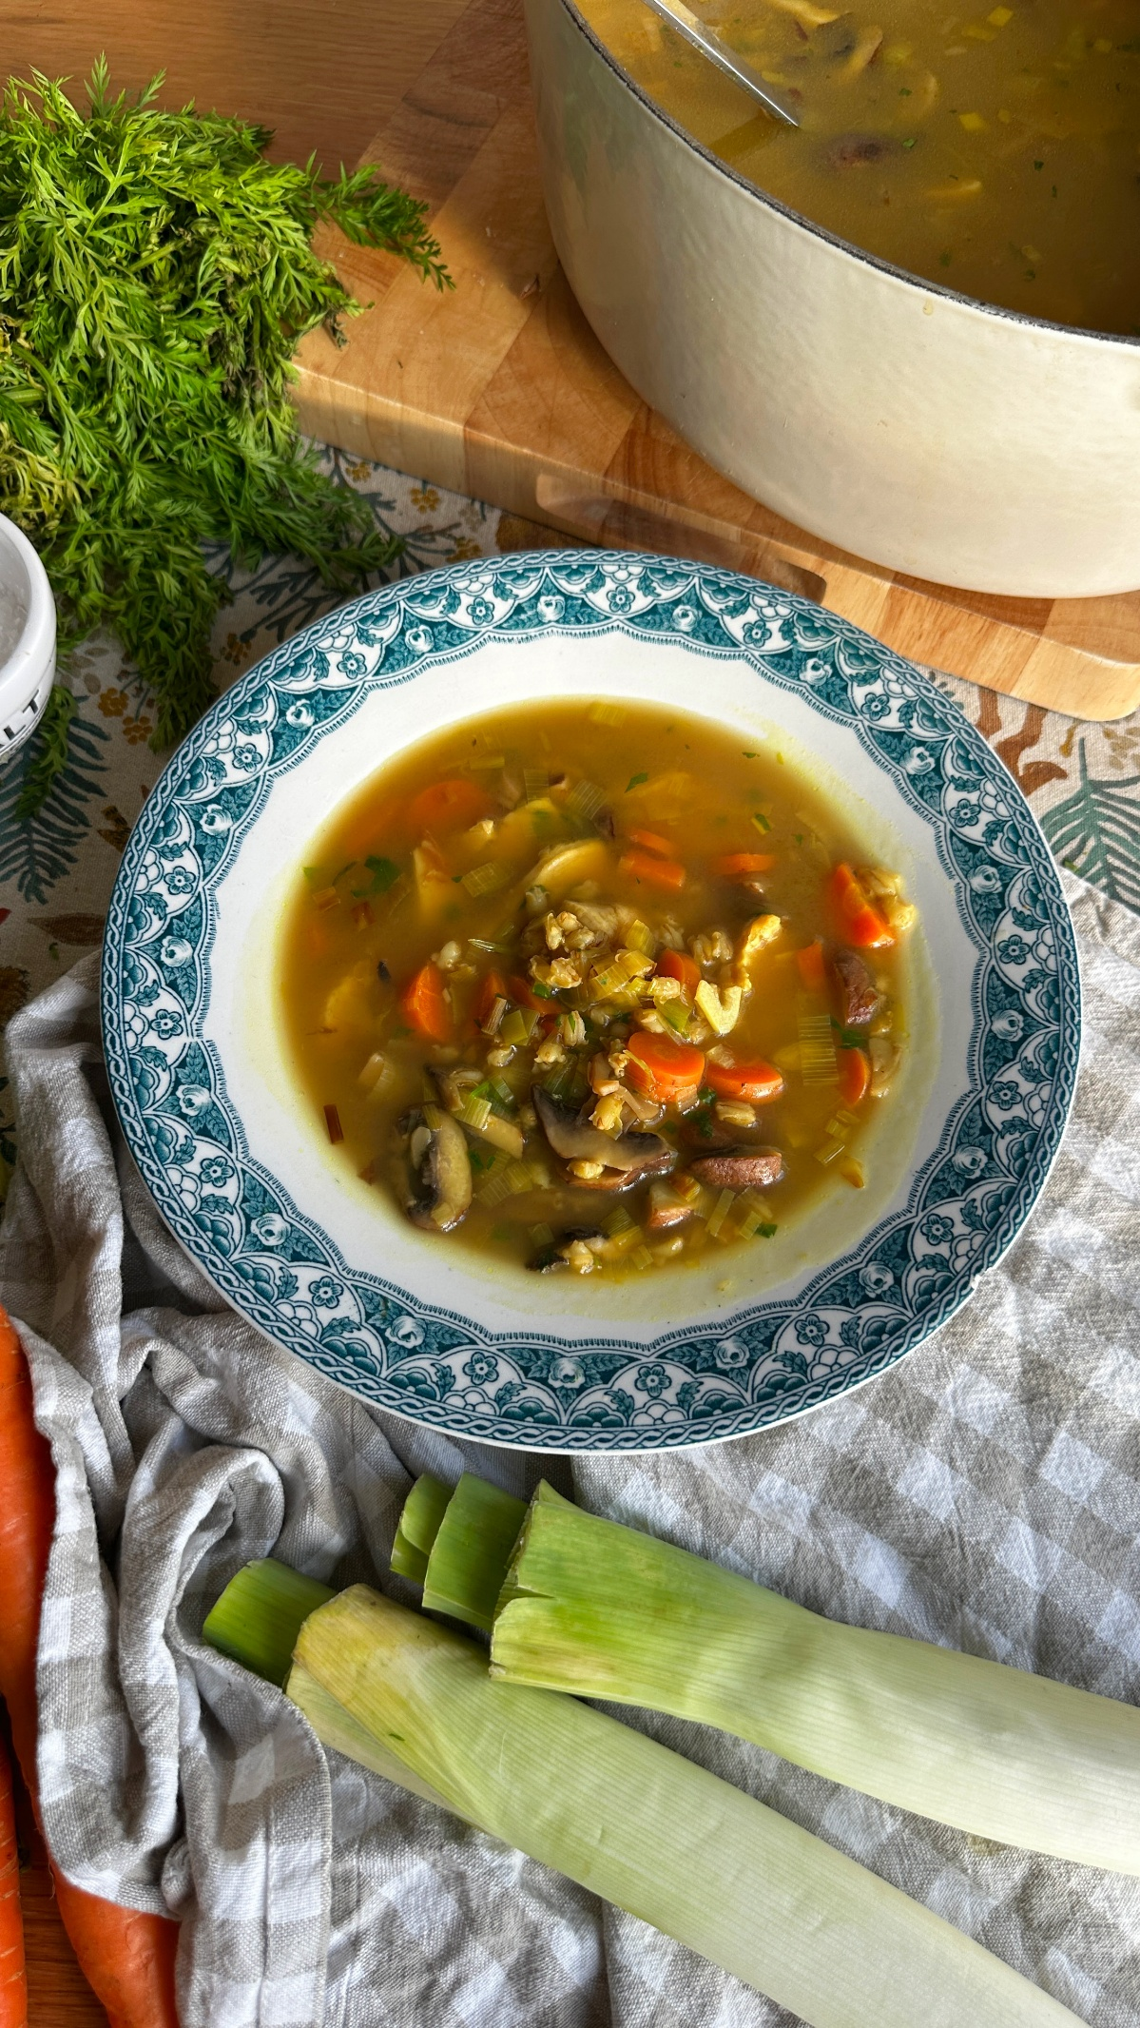
Serves 4
Prep time: 10 minutes
Cook time: 1 hour

Ingredients
180g pearl barley
700ml water (for cooking the barley)
1 tbsp olive oil
1 British leek, finely sliced
2 small carrots, finely chopped
2 garlic cloves, finely chopped
A couple of sprigs of fresh rosemary
200g chestnut mushrooms, roughly chopped
1.5 litres good-quality chicken stock
4 pre-cooked chicken breasts (around 480g)
Salt and black pepper, to taste
15g flat-leaf parsley, finely chopped

- Add the pearl barley to a saucepan with 700ml water, bring to the boil and cook for 25 minutes. Set aside.
- If cooking chicken from scratch, bake chicken breasts at 180°C (fan 160°C) gas mark 4 for 25 minutes. Otherwise, shop-bought pre-cooked chicken works perfectly here.
- In a large pot (around 2 litres), heat 1 tbsp olive oil over a medium heat.
Add one finely sliced British leek, two small carrots (finely chopped), two garlic cloves (finely chopped) and a couple of sprigs of rosemary.
Cook for around five minutes until softened, sweet and fragrant.
- Add the chestnut mushrooms, roughly chopped, and cook for a further two minutes.
- Pour in the chicken stock.
- Slice or shred the pre-cooked chicken breasts – keep the pieces chunky for a heartier broth, or shred finely if you prefer. Add to the pot along with the cooked pearl barley.
- Season with salt and pepper, cover with a lid and simmer gently for 20 minutes.
- Finish with parsley, finely chopped, stirred through just before serving.
A bowl of this feels like being looked after; simple, nostalgic, and quietly nourishing. British leeks really are the hero here: sweet, comforting and proudly local. Make a big batch, ladle it up all week, and enjoy!

Please credit www.Britishleeks.co.uk, photography, recipe & styling by JessHallCooks

