Highland Venison & Creamed Leek Pie with Ruff-Puff Pastry
In every fold of this Highland venison and creamed leek pie, I taste the echoes of my Scottish heritage - the mist rolling over heathered hills, the clatter of family gathered close, and the quiet comfort of a kitchen warmed by food made with love.
The leeks melt down the way my gran cooked them, soft and sweet, holding the heart of the dish the way our traditions hold the heart of me.
And when the ruff-puff rises, golden and proud, it feels like a little piece of home - a reminder that no matter where I wander, Scotland lives in my hands, my stories, and the food I share.

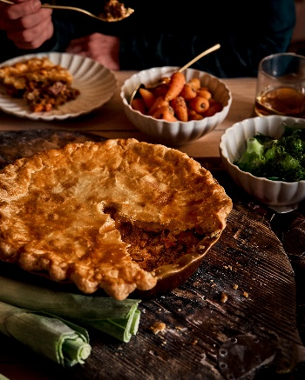
Serves 4
Prep time: 45-50 mins, pastry resting 90 minutes
Cooking time: 1hr 30 mins

Rough Puff Pastry
250g strong white flour
½ tsp fine salt
200g very cold unsalted butter, cut into small cubes
120–150ml ice-cold water
1 tsp lemon juice (optional, helps tenderness)

Venison Filling
600g venison shoulder or haunch, diced into 2cm pieces
2 tbsp plain flour
Salt & black pepper
2 tbsp butter (or 1½ tbsp oil)
3 large leeks, trimmed, halved lengthways, washed and sliced
2 garlic cloves, finely chopped
1 large carrot, diced
1 celery stick, diced
1 tbsp tomato purée
150ml red wine
300ml beef or venison stock
1 tbsp juniper berries, lightly crushed
1 bay leaf
1 tsp fresh thyme leaves
1 tsp mustard
75ml double cream
1 tsp redcurrant jelly (optional, but lovely)

To Finish
1 egg, beaten, for glazing
Flaky sea salt & cracked pepper

To Serve
Serve with buttery mash, braised red cabbage, or simply a tangle of more buttery leeks.

Method
- In a bowl, mix the flour and salt. Add the cubes of butter and lightly toss to coat. Add 120ml ice-cold water mixed with lemon juice. Bring together with a knife until a shaggy dough forms - visible butter lumps are perfect. Tip onto a floured surface, shape into a rectangle, and roll into a long strip. Fold the top third down and the bottom third up (like a letter). Turn 90 degrees. Roll again and repeat the fold. Wrap and chill for 30 minutes. Give it 3 more turns, chilling 20 minutes between each, then rest while you prepare the filling.
- Dust venison with flour, salt, and pepper. Heat oil/butter in a heavy pot. Brown the venison in batches until deeply caramelised. Remove and set aside.
- Add leeks to the same pot with a pinch of salt. Cook gently for 8–10 minutes until soft, sweet and velvety. Add garlic, carrot, and celery. Cook 5 minutes. Stir in tomato purée. Deglaze with red wine, reducing by half. Add stock, juniper, bay, thyme, mustard, and return venison to the pot. Cover and simmer gently for 45–60 minutes, until the venison is tender and the sauce rich. Stir in the cream and redcurrant jelly. Taste and adjust seasoning.
- Let cool completely - a cooled filling helps the pastry stay crisp.
- Preheat oven to 200°C (180°C fan) mark 6. Spoon the cooled filling into a pie dish.
- Roll out the ruff puff to about 4mm thick. Drape over the pie, trim the edges, and crimp prettily. Brush with beaten egg, sprinkle with a whisper of flaky salt. Cut a couple of steam vents. Bake for 35-40 minutes, until puffed, golden, and gloriously flaky.
- Let it rest for five minutes, then scoop generous portions into warm bowls. Serve with buttery mash, braised red cabbage, or simply a tangle of more buttery leeks (because one can never have too many).

Please credit www.Britishleeks.co.uk, photography, recipe & styling by Suze Morrison aka Gourmet Glow.

