Leek, Chicken, Apple & Somerset Cider Pie with a Crisp Potato Coin Top
In this leek, chicken, apple and Somerset cider pie, I taste the West Country I now call home - the orchards heavy with fruit, the quiet lanes edged with wildflowers, and the soft hum of countryside life that settles gently into your bones.

The leeks melt the way the evening sun slips over the fields, the cider brings that crisp orchard tang, and the apples remind me of autumn walks where every breath feels like a little blessing.

Topped with buttery potato coins that crackle like dried leaves underfoot, this pie feels like a love letter to the place that’s shaped me - warm, grounding, generous.
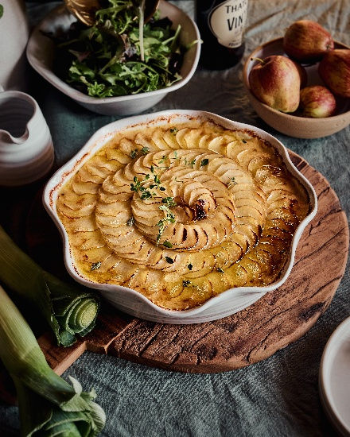
Serves: 4
Prep time: 25-30 mins
Cooking time: 1 hr 15 mins

Ingredients

For the Filling
2 tbsp butter
1 tbsp olive oil
3 large leeks, trimmed, halved lengthways and sliced
2 garlic cloves, finely chopped
500g boneless chicken thighs, cut into bite-sized pieces
1 large Bramley or 2 eating apples, peeled and diced
1 tbsp flour
250ml Somerset dry cider
150ml chicken stock
1 tsp mustard
1 tsp fresh thyme leaves
2 tbsp double cream
Salt & black pepper

Potato Coin Topping
450g waxy potatoes (Charlotte, Maris Piper), skin on
2 tbsp melted butter
Flaky sea salt & cracked pepper
A few thyme sprigs for finishing

Serve with buttered greens or a mustard-dressed salad

Method
- Heat the butter and oil in a wide pan over medium heat. Add the sliced leeks and a pinch of salt. Cook gently for 10 minutes until soft, sweet, and silky.
- Stir in the garlic and cook one minute. Add the chicken pieces and cook until lightly coloured. Add the diced apple and sprinkle over the flour; stir to coat.
- Pour in the cider and stock, scraping up any golden bits. Stir in mustard and thyme, then simmer gently for 12–15 minutes until the chicken is cooked and the sauce is lightly thickened. Add the cream, season generously, and remove from heat.
- Spoon into a pie dish and let cool slightly while you prepare the topping.

- Preheat the oven to 200°C (180°C fan) gas mark 6. Slice the potatoes into 3-4mm coins (skin on for rustic crispness). Toss in melted butter, salt and pepper. Lay the coins in overlapping concentric circles over the filling. Brush with any remaining butter. Bake for 40-45 minutes until the potatoes are crisped at the edges and deeply golden, and the filling bubbles up around them.
- Sprinkle with fresh thyme and a pinch of flaky salt before serving. This dish is perfect with buttered greens, a mustard-dressed salad, or just a big spoon and a quiet moment of happiness.

Please credit www.Britishleeks.co.uk, photography, recipe & styling by Suze Morrison aka GourmetGlow.

