Leek & Herb Toad in the Hole with Leek Gravy

A spring-ready twist on a British classic, celebrating the gentle sweetness and softness of British leeks.
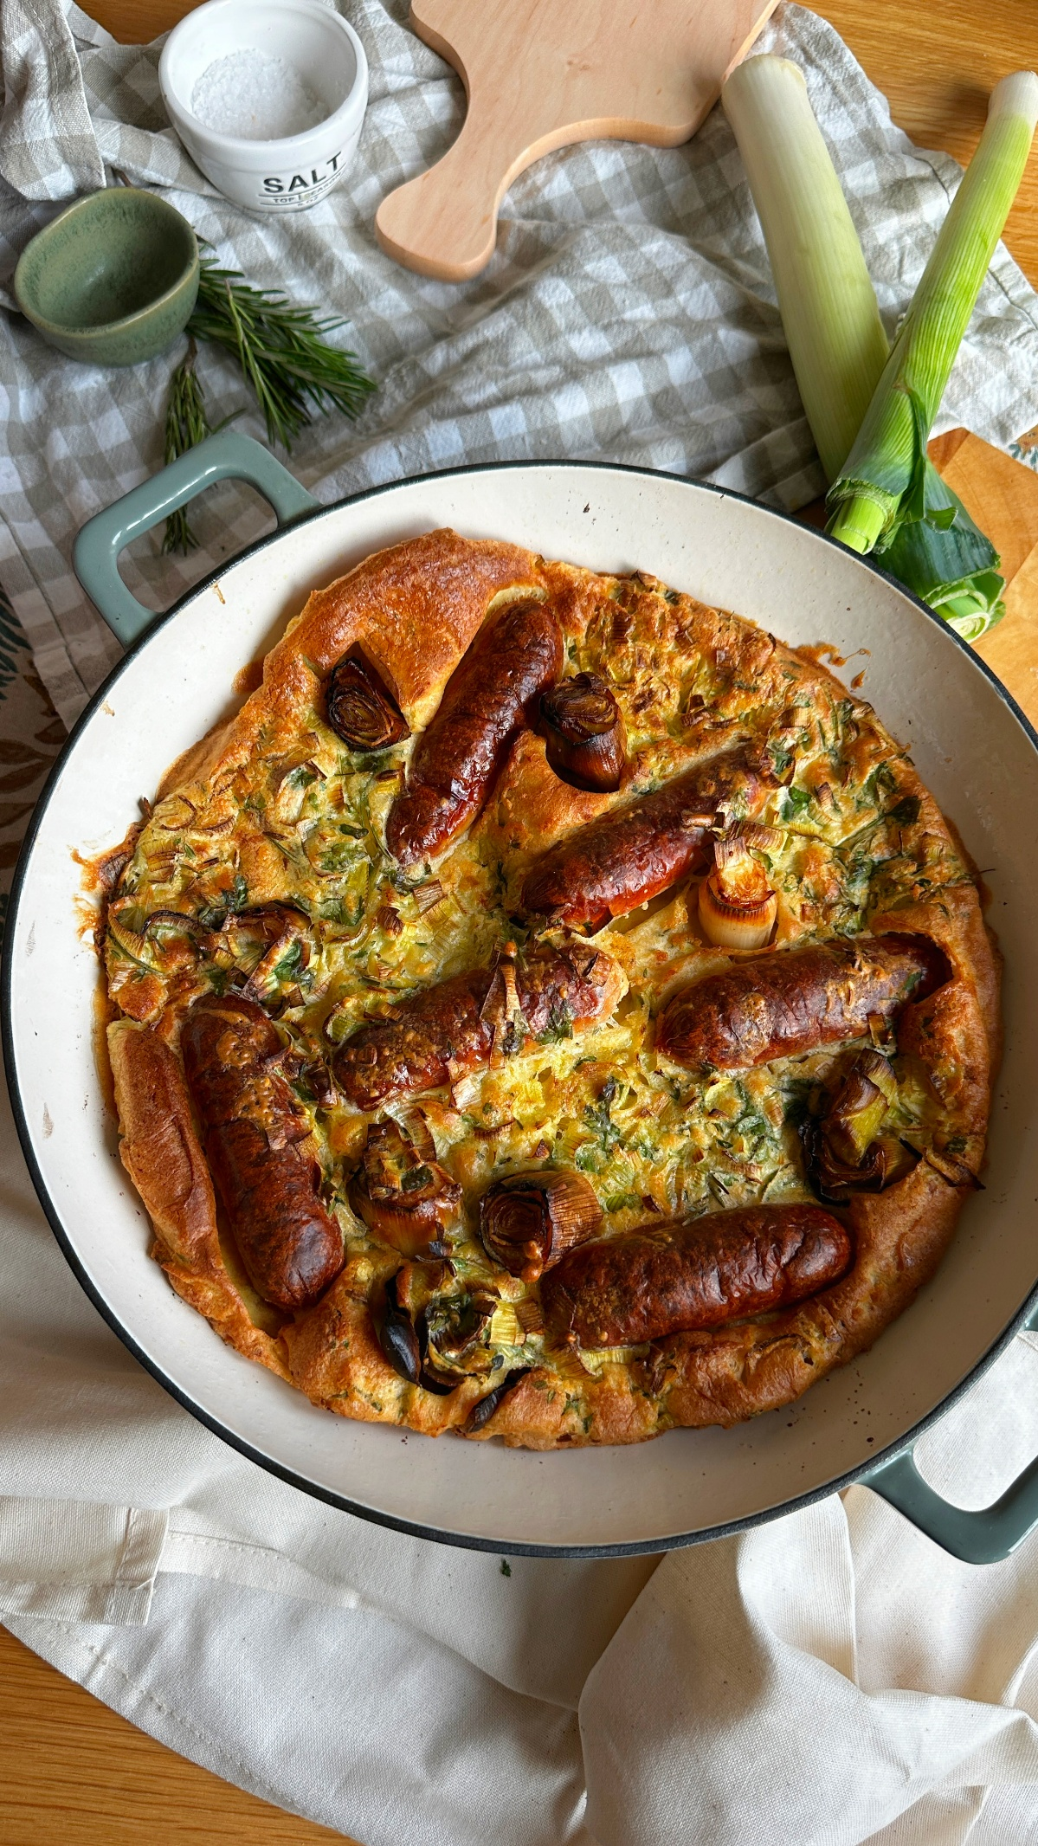
Serves 4
Prep time: 10
Cooking time: 1 hr 5 mins

Ingredients
For the toad in the hole
150g plain flour
Pinch of salt
3 eggs
200ml semi-skimmed milk
50ml water
½ leek, very finely shredded
A large handful of fresh herbs (rosemary, thyme, parsley), finely chopped
2 tbsp sunflower oil
8 sausages (around 450g)
1 leek, chopped into roughly 5cm pieces

For the leek gravy
2 tbsp butter
1 leek, finely shredded
2 tbsp plain flour
400ml beef stock
2 tbsp gravy granules

Method
- Make the batter
Add the flour and salt to a bowl. Whisk in the eggs until you have a very thick, smooth paste. Gradually add the milk in stages, whisking well each time, then whisk in the water until the batter is completely smooth. Fold through the finely shredded leek and the chopped herbs. Set aside to rest while you prepare the sausages.
- Roast the sausages and leeks
Preheat the oven to 240°C (fan 220°C) gas mark 9. Add the sunflower oil to a metal roasting dish and place it in the oven to heat. Carefully remove the hot dish, add the sausages and chopped leek pieces, and turn everything so it’s well coated in the oil. Return to the oven and roast for 10 minutes, until the sausages are starting to colour and the leeks are softening.
- Bake the toad in the hole
Remove the dish from the oven and carefully pour the batter around the sausages and leeks. Return to the oven, reduce the temperature to 200°C (fan 180°C) gas mark 6, and bake for 30 minutes, without opening the oven for at least the first 25 minutes, until risen, crisp, and deeply golden.
- Make the leek gravy
While the toad in the hole cooks, melt the butter in a saucepan over a medium heat. Add the finely shredded leek and cook gently for about 5 minutes, until soft, silky, and sweet.
Stir in the flour and cook for 2 minutes, then gradually whisk in the beef stock. Simmer until thickened, then stir through the gravy granules towards the end for extra depth and umami.

- Serve
Serve the toad in the hole immediately, spooned generously with the leek gravy.

Please credit www.Britishleeks.co.uk, photography, recipe & styling by JessHallCooks

