Leek & Tomato Fish Stew
Just five minutes from my cottage kitchen lies Weymouth Bay - where the tide rolls in with stories, salt, and the freshest fish you could hope to cook with.
There’s something magical about walking home with the sea breeze still clinging to your hair, setting leeks to melt in a pot while the gull’s wheel overhead outside.
Cooking this simple British fish stew feels like stirring the coastline itself into the broth - bright tomatoes, sweet leeks, and fish caught almost within sight of my doorstep.
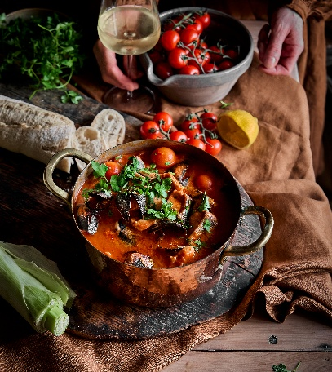
Serves: 4
Prep time: 20 mins
Cooking time: 35-40 mins

Ingredients

Base
2 tbsp olive oil
3 large British leeks, trimmed, halved and finely sliced
1 small onion, diced
3 garlic cloves, finely chopped
1 tsp English mustard powder (or ½ tsp grated fresh British horseradish)
1 tbsp tomato purée
400g tin tomatoes
200g fresh baby tomatoes
400ml fish stock
1 bay leaf
A few thyme sprigs

Fish & Finishing
200g sustainably caught British white fish (hake, haddock, pollock or cod), cut into chunks
200g Fresh British River Trout, cut into chunks
200g British mussels or cooked brown shrimp (optional)
1 tbsp butter
Juice of ½ lemon
A handful of chopped parsley
Sea salt & black pepper

To Serve
Crusty bread or homemade sourdough
Butter (optional but encouraged)

Method
- Warm the olive oil in a wide pot over medium heat. Add the leeks with a pinch of salt and cook 10 minutes until softened and sweet. Add the onion and garlic; cook 3-4 minutes.
- Sprinkle in the mustard powder and stir for 30 seconds. Add the tomato purée and cook for a minute to deepen the flavour. Pour in the tinned & fresh tomatoes and fish stock. Add bay and thyme, then simmer gently for 15 minutes.

- Taste and season the broth. Nestle in the fish pieces and simmer 5-7 minutes until just opaque and flaking. Add mussels for the final 3 minutes if using, cover, and let them steam open. Stir in the butter, lemon, and parsley. Adjust seasoning - the stew should taste fresh, clean, and coastal with a warming hum from the mustard.
- To serve - ladle into bowls and serve with thick slices of crusty British bread to mop up the broth.

Please credit www.Britishleeks.co.uk, photography, recipe & styling by Suze Morrison aka GourmetGlow.

