Potato, Leek and Cheddar Pie with Leek Lattice (A Take on Homity Pie)

This is a comforting, rustic take on a classic homity pie - floury potatoes folded with buttery leeks, thyme, and sharp mature cheddar, all baked in crisp shortcrust pastry. Finished with an optional leek lattice topping, it’s a beautiful centrepiece that feels traditional yet quietly elegant, nostalgic and fun.

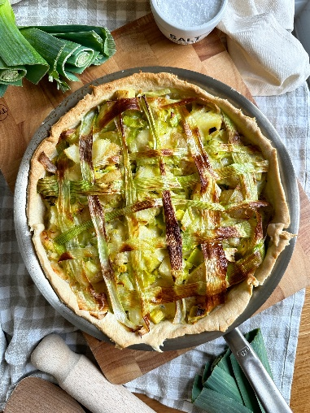
Serves 4
Prep time: 20 minutes
Cooking time: 50 minutes

Ingredients

For the filling
800g floury potatoes (such as Maris Piper or King Edward), cut into quarters
2 tbsp butter
2 leeks, finely sliced
3–4 sprigs fresh thyme, leaves only
Salt and freshly ground black pepper, to taste
100ml crème fraîche
200g mature cheddar (strong and well-aged), crumbled

For the pastry
1 sheet ready-rolled shortcrust pastry
For the leek lattice (optional)
1 leek

To serve
Steamed green vegetables or a fresh green salad

Method

- Preheat the oven to 180°C / 356°F / 160°C fan / Gas mark 4.
- Bring a large pan of salted water to the boil. Add the potatoes and cook for 12–15 minutes, until fork-tender. Drain well and return them to the pan, leaving them to steam dry for a few minutes to remove excess moisture.
- In a large, shallow 30cm ovenproof pan, melt the butter over medium heat. Add the finely sliced leeks and cook gently for around 5 minutes, until softened and sweet but without allowing them to brown.
- Strip the thyme leaves from the woody stems by running your fingers down the stalks against the direction of growth, then stir them into the leeks. Remove from the heat.
- Transfer the potatoes to a large mixing bowl. Add the buttery leeks and thyme, season generously with salt and black pepper, then spoon in the crème fraîche.
- Add the cheddar, crumbling it into the bowl with your fingers so you get a mix of small and larger pieces.
- Gently mix everything together, pressing on a few of the potatoes to slightly mash them while keeping most of the chunks intact - this gives the pie both structure and softness.
- Line the same pan you cooked the leeks in with the shortcrust pastry, letting the excess hang over the edges.

- Spoon in the potato, leek, and cheese mixture and gently level the top.
- At this point, you can simply fold over the pastry edges and bake - or continue with the leek lattice topping for a more decorative finish.
- To make the leek lattice (optional). Slice the leek lengthways down the centre and carefully separate the layers into long strips.
- Bring a pan of water to the boil and simmer the leek strips for 20–30 seconds, as you would spaghetti, just until pliable. Immediately transfer them to a bowl of iced water to stop the cooking, then drain and pat dry.
- To create the lattice: Lay half of the leek strips horizontally across the pie, evenly spaced. Fold back every other strip halfway. Lay a vertical strip of leek across the centre. Fold the horizontal strips back over it. Repeat with more vertical strips, alternating which horizontal strips you fold back each time, until you have a simple criss-cross pattern.
- Carefully lift the finished lattice and place it over the pie.
- Bake in the preheated oven for 30 minutes, or until the pastry is golden and crisp and the filling is piping hot.
- Serve warm with steamed green vegetables or a crisp green salad for contrast.

Please credit www.Britishleeks.co.uk, photography, recipe & styling by JessHallCooks

