Spring Green Cock-a-Leekie Soup with Peas, Mint & Lemon
There’s something about a pot of spring green cock-a-leekie simmering away that feels like a love letter to the season… and to the simple, quiet moments that make life soft.

Leeks melting into sweetness, barley swelling with comfort, roast chicken falling into tender ribbons, peas and mint adding that hopeful green that whispers spring is coming. A squeeze of lemon, a stir of warmth, a bowl shared with someone you adore.

It’s not just soup - it’s a gentle kind of togetherness, the kind that fills the kitchen with steam and the heart with ease.
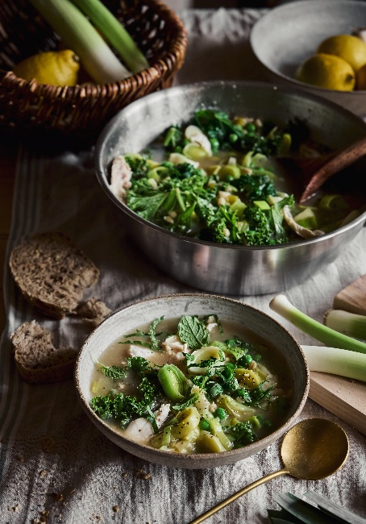
Serves 4
Prep time: 20-25 mins
Cooking time: 50-60 mins

Ingredients

Roast Chicken
4 bone-in chicken thighs
1 tbsp olive oil
Salt & black pepper
Zest of ½ lemon

Soup Base
1 tbsp butter
1 tbsp olive oil
3 large leeks, sliced (white + pale green)
2 garlic cloves, finely chopped
1 litre good chicken stock
60g pearl barley (about ⅓ cup), rinsed
150g spring greens or cavolo nero, finely shredded
200g baby peas (fresh or frozen)
Zest of 1 lemon + juice of ½–1 lemon (to taste)
Small bunch fresh mint, chopped (reserve some for serving)
Salt & black pepper
Optional: ¼ tsp white pepper

To Serve
Extra mint leaves
Lemon wedges
Freshly cracked black pepper
Drizzle of olive oil

Method
- Heat oven to 200°C (180°C fan) gas mark 6. Place chicken thighs on a tray, rub with olive oil, salt, pepper and lemon zest. Roast for 25–30 minutes or until golden and cooked through. Rest, then shred the meat from the bones. Save any roasting juices.

- In a large pot, melt the butter with the olive oil over medium heat. Add the leeks and a generous pinch of salt. Cook low and slow for about 10 minutes until soft and sweet but not coloured. Add garlic and cook 1 minute more.
- Pour in the chicken stock and the roasting juices. Add the rinsed pearl barley. Bring to a gentle simmer and cook for 25–30 minutes, stirring occasionally, until the barley is plump and tender.
- Add the shredded spring greens and cook for 5–7 minutes until just tender. Add the peas and cook 3 minutes. Stir in the shredded roast chicken. Add lemon zest and juice to taste - you want a clean, bright lift.
- Stir through most of the chopped mint. Taste and adjust seasoning with salt, black pepper, and white pepper if using.
- Ladle into warm bowls and finish with extra mint leaves, a squeeze of lemon, a crack of black pepper, and a drizzle of olive oil.

Please credit www.Britishleeks.co.uk, photography, recipe & styling by Suze Morrison aka GourmetGlow.

